Perform and explain the code flow and the associated result for the below tasks. Candidates should

create and use their own employee dataset for the same. Share the screenshot of the commands used

and its associated result.

● Transfer data between Mysql and HDFS (Import and Export) using Sqoop.

Create database school;

create table student

(

std_id int,

std_name varchar(20),

std_class varchar(20)

);

insert into student values(1, ‘sai’,'Btech');

insert into student values(2, 'durga','Mtech');

insert into student values(3, 'Vignesh','Phd');

grant all on *.* to 'root'@'localhost' with grant option;

flush privileges;

commit;

sqoop import --connect jdbc:mysql://localhost/school --username 'root' -P --table 'student' --target-dir '/user/sqoopinput1' -m 1;

**Import Data**

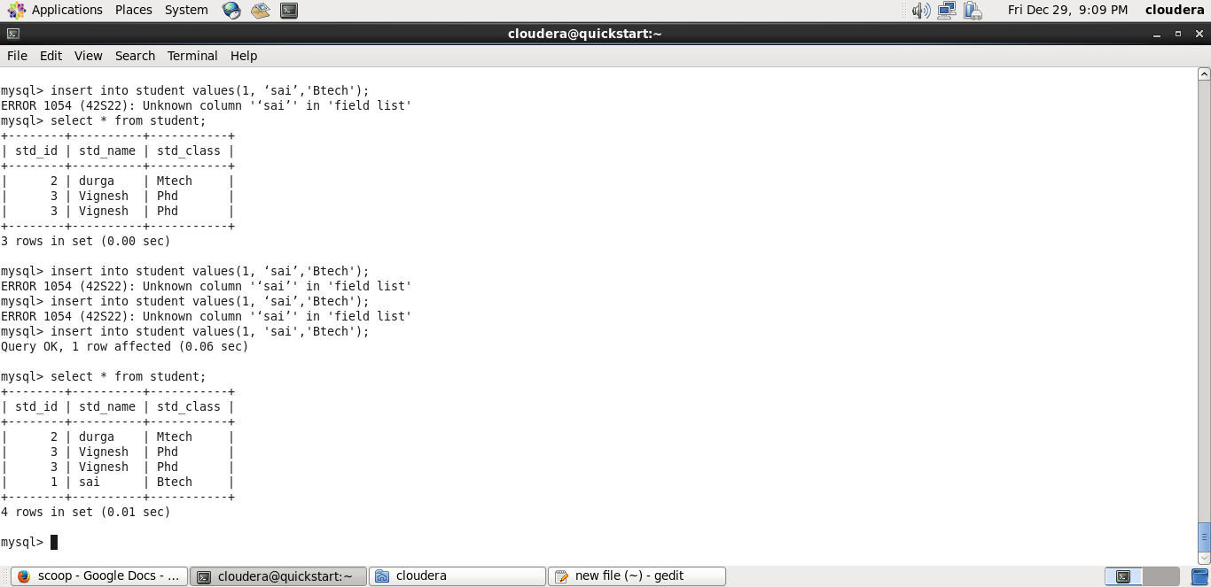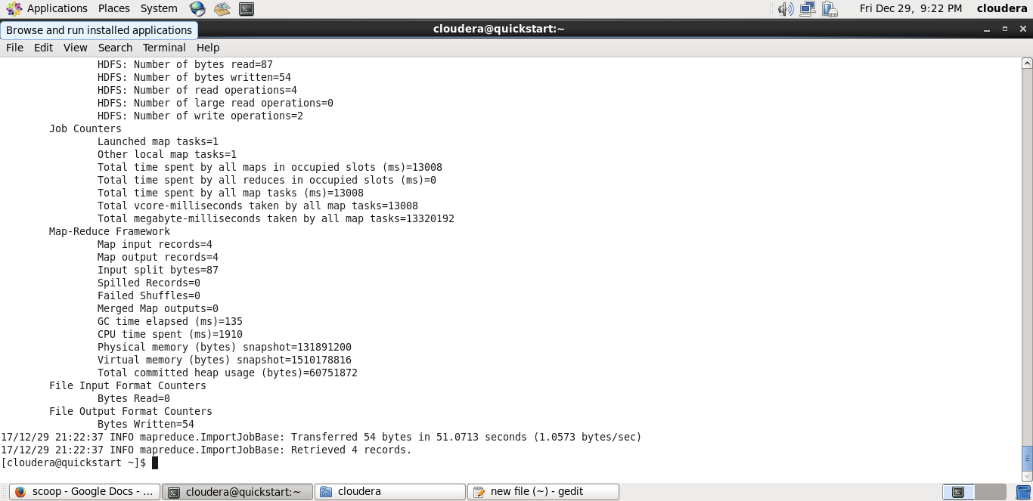

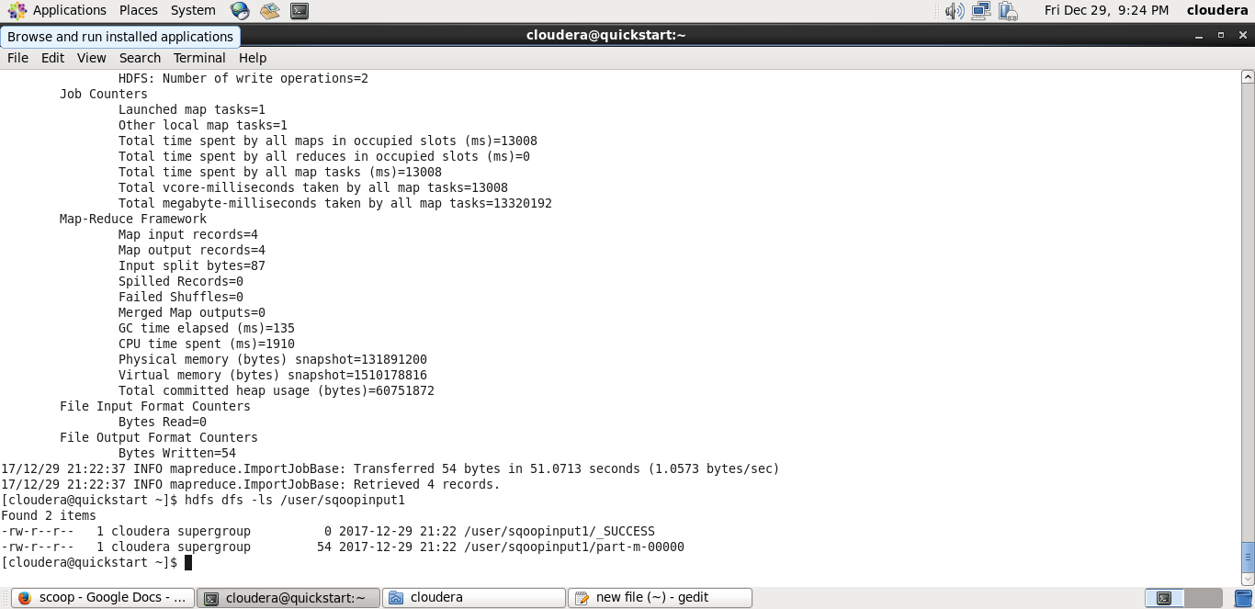

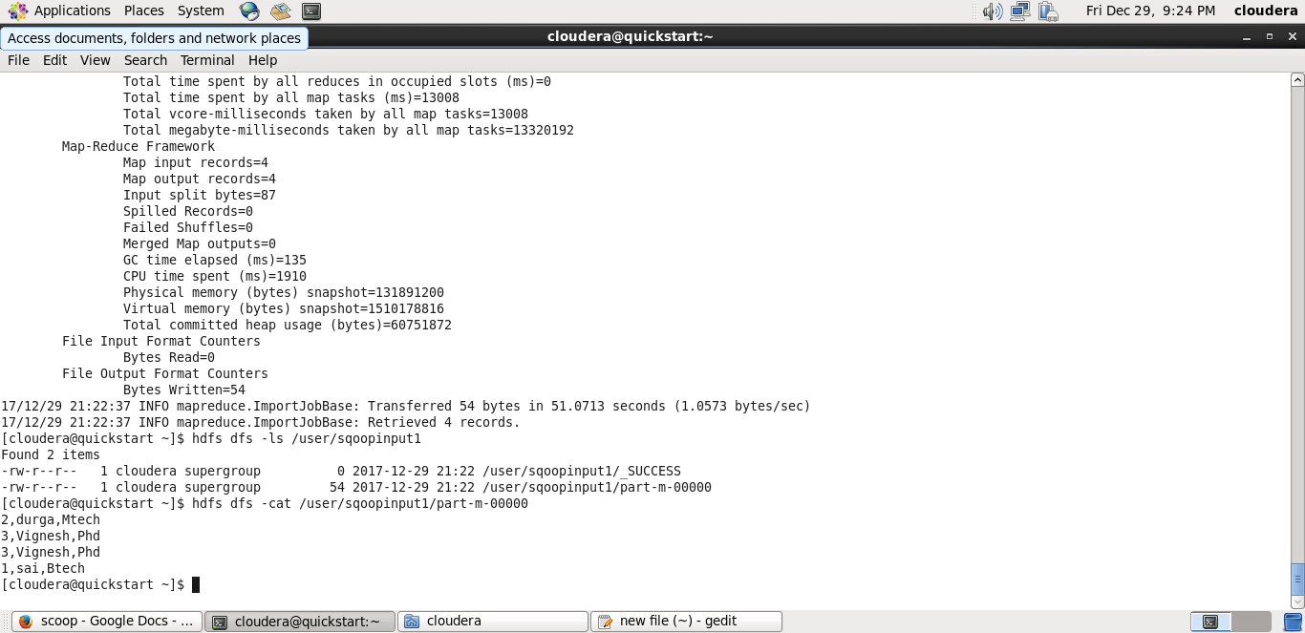

**Export Data**

Create table students_data

(

StudentName varchar(50),sector varchar(50),DOB varchar(50),qalification varchar(50),score varchar(50),state varchar(50),randomName varchar(50)

)

sqoop export --connect jdbc:mysql://localhost/school --username 'root' -P --table 'students_data' --export-dir '/user/student.txt' --input-fields-terminated-by ',' -m 1 --columns StudentName,sector,DOB,qalification,score,state,randomName

Student.txt is the file while is used for move data from pig to hbase in 10.2 assignment. Using the same file to export to mysql database;

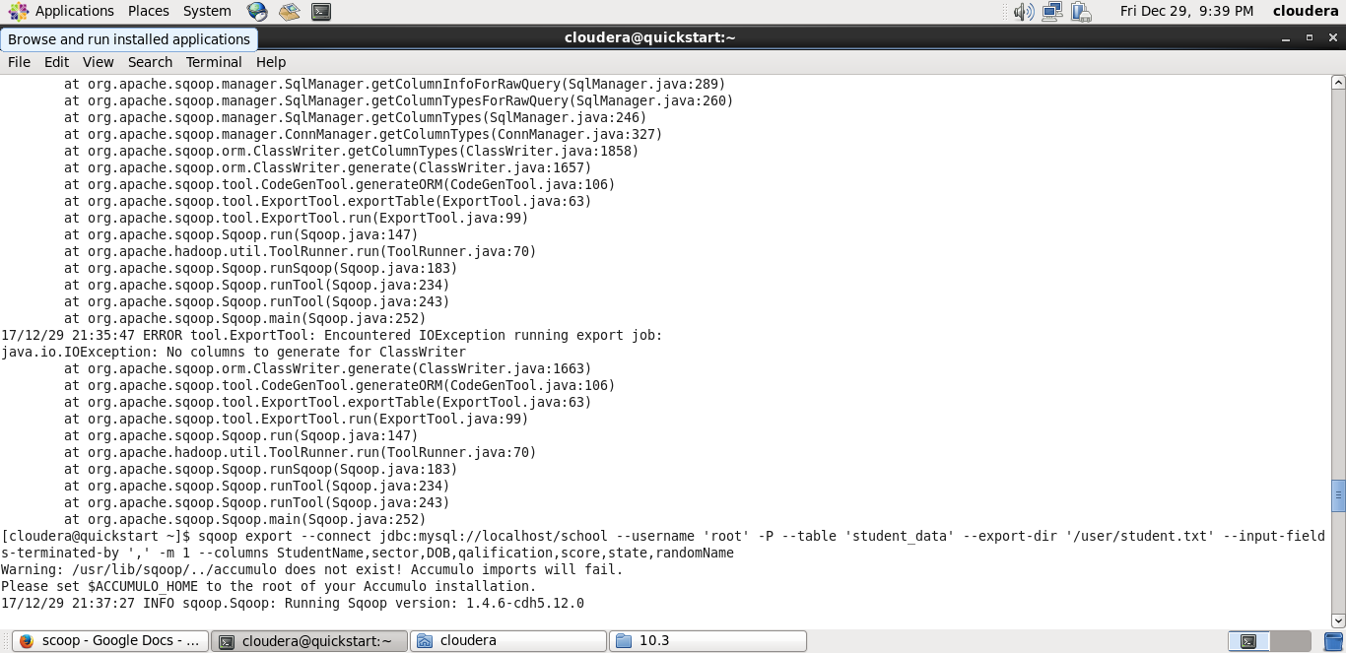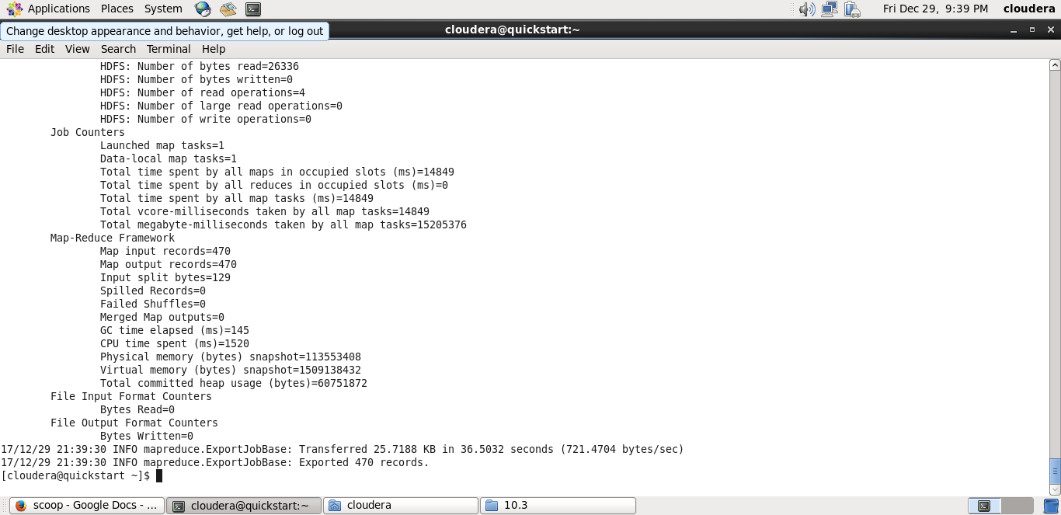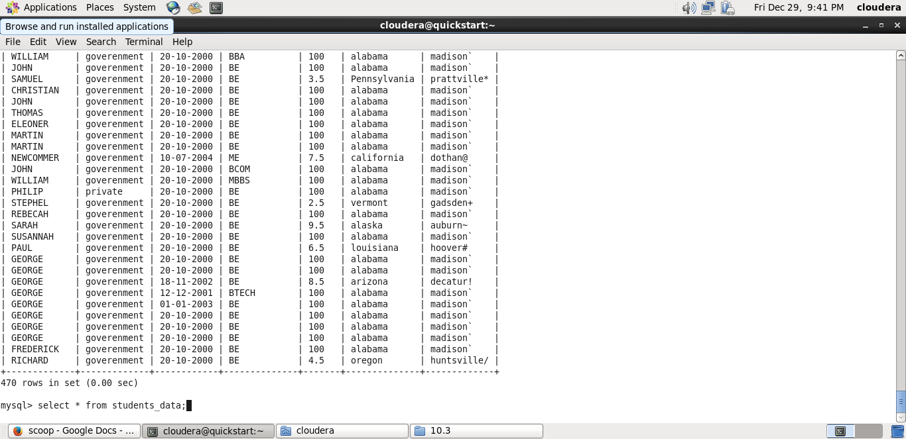

● Transfer data between Mysql and Hive (Import and Export only selected columns) using Sqoop.

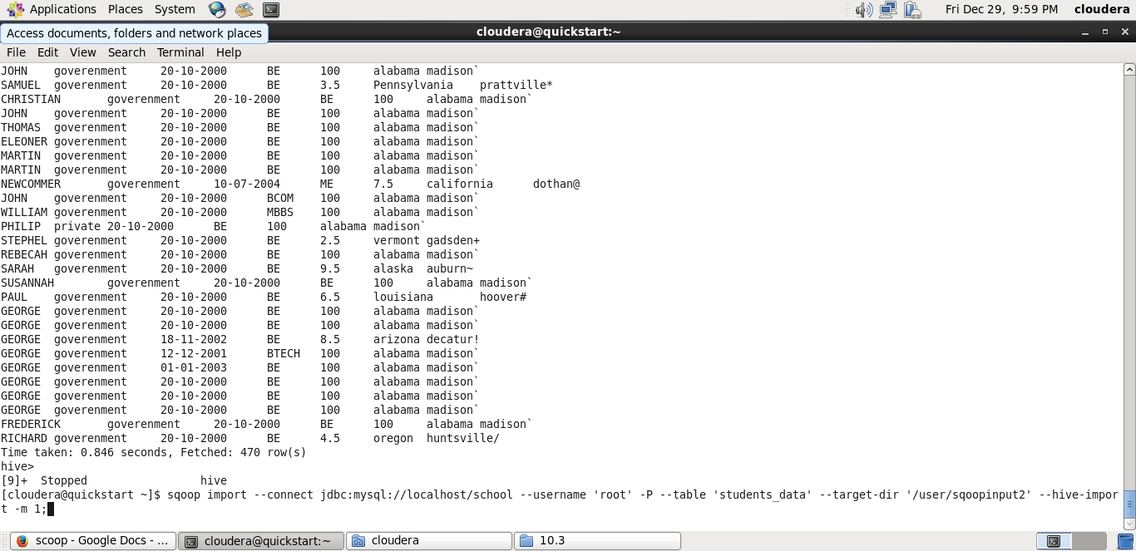

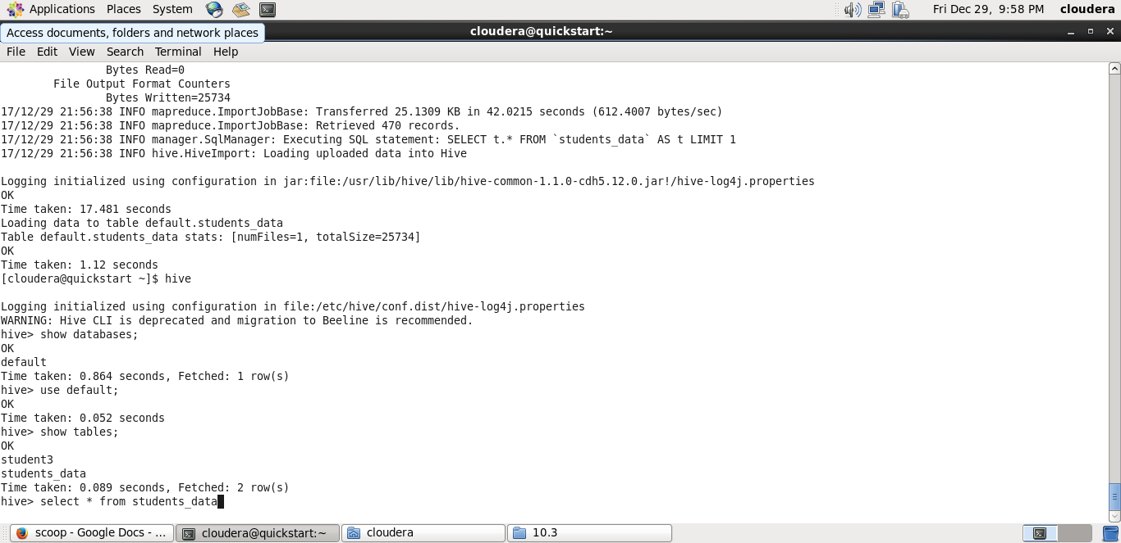

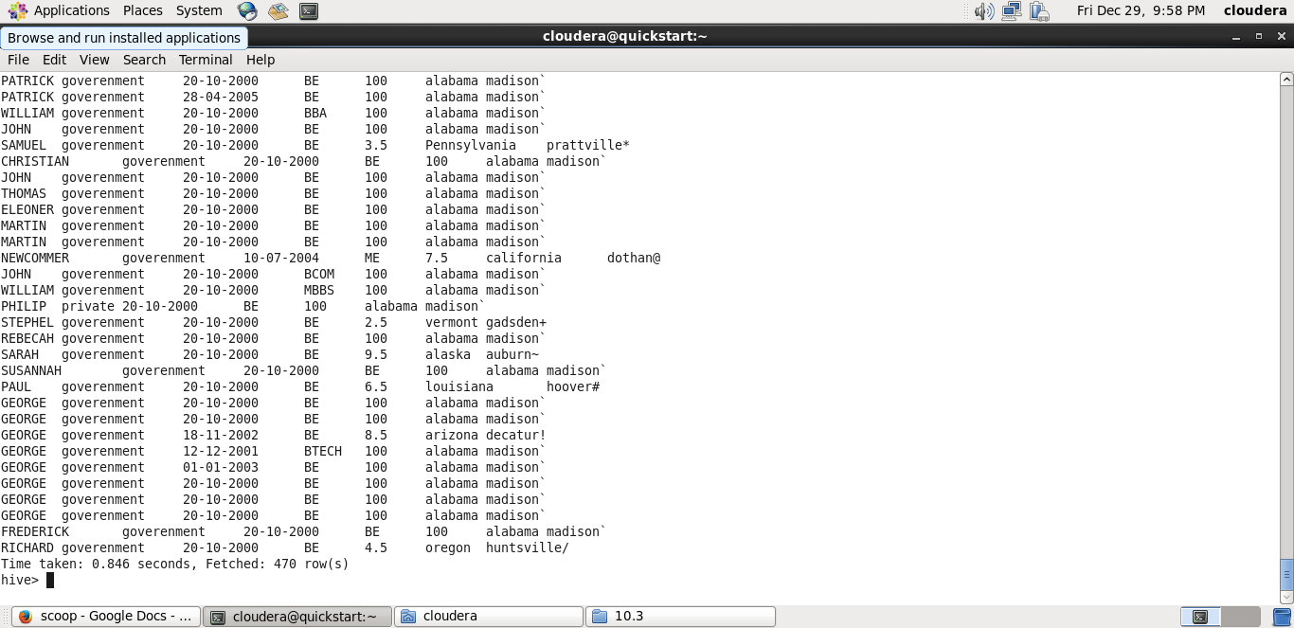

Hive Export

sqoop export --connect jdbc:mysql://localhost/school \

--username root \

      -P \

      --table names \

      --export-dir  hdfs://quickstart.cloudera:8020/user/usernames \

      --input-fields-terminated-by ',' \

      --input-lines-terminated-by '\n' \

      --num-mappers 2 \

      --batch \

      --outdir java_files



